**Outputs**

**Visualize scene distribution:**

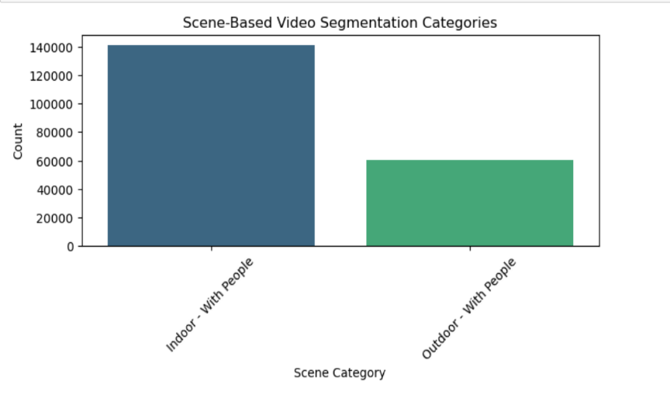

**This output shows:** A **bar chart** where, the **x-axis** represents different **scene categories**.The **y-axis** shows the **number of occurrences** for each category.The bars are **color-coded** using the **Viridis palette**.The **title and axis labels** provide context.

**Indoor scenes:**

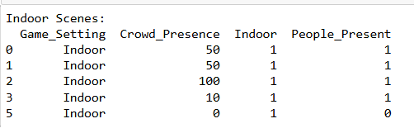

This code **filters and displays indoor scenes** from the dataset. Prints the **first 5 rows** of indoor scenes. Helps to quickly inspect the filtered dataset.

**Outdoor scenes:**

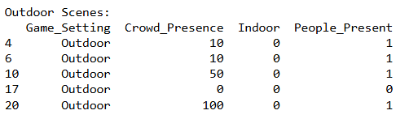

This code **filters and displays outdoor scenes** from the dataset. Prints the **first 5 rows** of outdoor scenes. Helps to quickly inspect the filtered dataset.

**Scenes with People Present:**

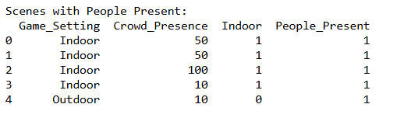

This code **filters and displays scenes where people are present** from the dataset. Prints the **first 5 rows** of people present scenes. Allows for a quick inspection of the filtered dataset.

**Scenes without People Present:**

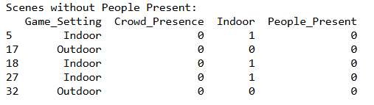

This code **filters and displays scenes where people are present** from the dataset. Prints the **first 5 rows** of people present scenes. Allows for a quick inspection of the filtered dataset.

**Classifies scenes based on indoor/outdoor settings and people presence:**

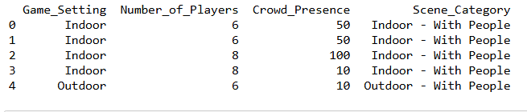

**Classifies scenes where there are no players and no crowd:**

